Table of Contents

Access the System 2

Open a New Requisition 2
Initiate/Open a Recurring Requisition 3

Update / Edit Existing Requisition 4

Enter Schedules (Force Desk Only) 4
Edit Schedules (Force Desk Only) 5

Approve/Decline a Requisition 6

Assign a Trainer/Classroom to an Approved Requisition 6
Make Changes to an Assigned Training Class 7
To adjust a Training Class Schedule 8
To delete an assigned Training Class 8
Recruiting 8
To enter the # to be Recruited and the # to Begin Class 9
To insert a record into the Welcome Log (new or existing) 9
To drop a candidate from the Welcome Log 10
To reactivate a candidate previously dropped from the Welcome Log 10
To update a Welcome Log entry (before or after class has begun) 10
To update the BG status (Background Check) formerly Pending Paperwork10
To update the Pending Second Interview status 10
To complete a Welcome Log on first day of training 11
To add entries to a Welcome Log once class has begun 11
To change the Bilingual status of an agent once class has begun 12
To modify a candidate’s name on the Welcome Log 12
To reactivate a termed agent during training 12
To transfer a candidate from one Wel Log to another prior to class 13
To transfer an agent from one class to another during training 13
Welcome Log – HR 14
To enter an ABRA number for a new hire that starts class late 14
Welcome Log – Payroll 14
Welcome Log – Force Desk 15
Training Class Attendance 15
To view training hours (Training use only) 15
To terminate an agent from class 15
To complete a Training Log 17
To complete a Training Class 17
To transfer an agent from one class to another during training 17
To change the Bilingual status of an agent during training 12
To reactivate a termed agent during training 12

Training Log (view only) 18
To print a Training Log 18
To view Training Payroll Hours (Program Managers/Recruiting/HR) 18
Close a Requisition / Change the Status of a Requisition 19
Open a Sub-Requisition 19
View Declined/Cancelled/Closed Requisitions (historical data) 20
Maintenance 21
The maintenance section is used to maintain the following information; only the parties shown below can access and update the maintenance section:
- Trainer Detail Training Manager
- Classroom Detail Training Manager
- Recruiter Detail Recruiting Manager
- Employment Sources Recruiting Manager
- Agent Profiles Program Manager
Drop & Term Codes for Recruiting / Training 22

Access the System
- Log onto Informant. If you do not have a shortcut to Informant on your desktop, open the Internet and type Informant in the internet address field – the login screen will appear. (From the Login screen you can get your password if forgotten, change your existing password, or request a User Name and Password.)
- Once Informant is open, user options will be listed on the menu located along the left side of the screen.
  - On the Informant menu expand the USE option and select the Automated Requisition and Training System listed below it.

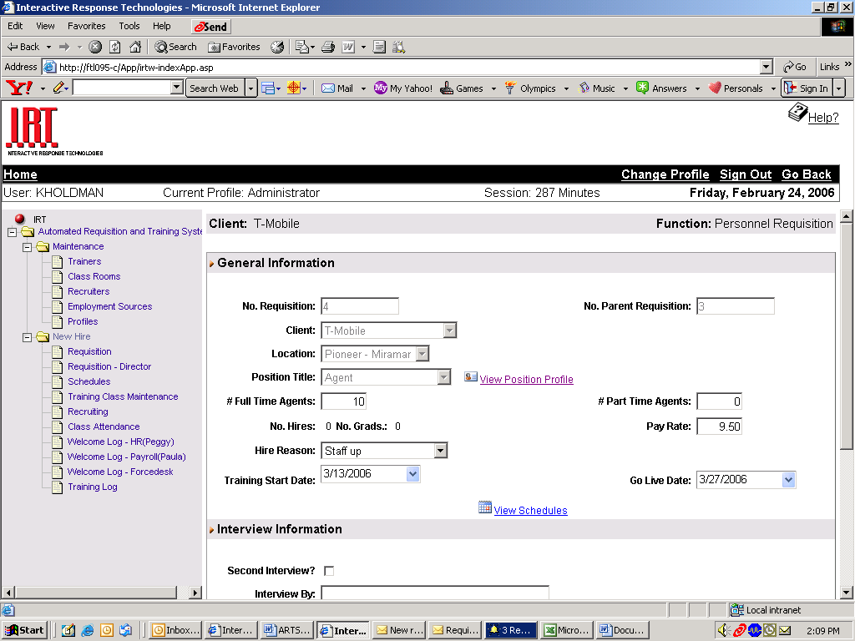
Requisition

Open a New Requisition
- A menu will appear along the left of the screen;
NOTE: Options will be limited based on the user level. A list of possible menu items is displayed at right.
- Select Requisition listed under New Hire
- Select NEW (You do NOT need to select Client or Status first)
- Once the New Requisition form appears:
General Information
- Select Client (drop-down list)
- Select Location (drop-down list)
- Select Position Title (Agent) (drop-down list)
- IMPORTANT: The Agent Profile will appear once Agent is selected for Position Title. The Program Manager can make changes to the Profile if needed (See Maintenance)
NOTE: If Agent is not an option listed under Position Title, this is an indication that your Agent Profile is not loaded into ARTS. To insert your Agent Profile, see Maintenance.

If you would like the position posted throughout IRT internally as a job posting, check the Internal box. If you would like IRT to advertise the position externally, check the External box. Both boxes can be checked.

Enter the number of Full Time Agents and Part Time Agents that you will need on the floor. IMPORTANT: This number should represent the number you would like “out” of training.

Pay Rate will auto populate based on the client chosen. NOTE: If the Pay Rate does not populate enter the correct pay rate for the position in a 0.00 format.
- Enter Hire Reason (drop-down list)
- Check Incentive if your program offers an incentive on top of the base pay rate.
- Enter the Training Start Date – this represents the date you would like training to begin – this date will be pending until confirmed by the Training Manager. IMPORTANT: Allow at least 2 weeks for recruiting.
- Enter Go Live Date: this is the date the new agents will hit the floor, allowing for recruiting (2 weeks) and training time.

Interview Information
- If a second interview is required by a member of the Operations management team, insert a checkmark next to Second Interview
- Once the Second Interview button is selected, indicate who will be conducting the second interview by highlighting the name in the Select Interviewer box. Once a name is selected, click on the right arrow button to place the selected name in the Interview By box.
NOTE: only names of the Operations Management Team for the specific program will appear in the Select Interviewer box (Supervisors, Operations Managers, Program Manager).
To remove a name from the Interview By box, simply highlight the name and select the left arrow button to return the name to the Select Interviewer box.
NOTE: a maximum of 3 names can be placed in the Interview By box
Requisition Status
- On a NEW requisition, the status will default to Pending, and remain in the Pending status until approved by EVP.
- To insert Comments select the Add Comment button.
- The following should be indicated in the Comments section:
- Number of bilingual agents needed. Example: 5 of the 10 Full Time Agents needed should be bilingual.
- If your account is an outbound account with multiple shift schedules, please indicate what shift(s) you would like filled.
- If the training class will be Billable or Non-Billable
- Any additional information that you feel would be relevant.
- Once the comment is entered, select Add in the Comments box
- Once the entire New Requisition is complete, select ADD to process the requisition

- Notification E-mail
Subject Line: | A new requisition has been created for (Account Name)
Content: | A new requisition has been created for (Account Name) Requisition # _. Please create schedules.

Initiate/Open a Recurring Requisition

NOTE: This will be used to open a requisition that will contain the same or similar requirements as a previous requisition. In order to use this function you must have already entered a requisition through ARTS that has been Approved.
- Select Requisition listed under New Hire on the ARTS menu (left-hand side of screen)
- Select the appropriate Client
- For Status, select either Approved or Closed
- Select the most recent requisition from the list that appears
- Scroll down to the Requisition Status section
- Select New Recurring
- A new requisition will open containing the same information as the previous requisition chosen
- Click on the View Profile link and make any necessary changes to the Agent Profile
- Make any necessary changes to
  - Position Posted
  - # Full Time Agents
  - # Part Time Agents
  - Pay Rate
  - Hire Reason
  - Incentive
- Enter a Training Start Date
- Enter a Go Live Date
- Make any necessary changes to Interview Information
- Add Comments as needed (see Requisition Status under Open a New Requisition above)
- Select Add to submit the Recurring Requisition

Update / Edit an Existing Requisition
NOTE: this would be used when any details of an existing requisition changes, such as Required Headcount, Hire Reason, Pay Rate, etc. or when you would like to add Comments to an existing requisition.
- Select Requisition listed under New Hire
- Using the search criteria of Client and Status, locate the requisition you would like to edit. Only requisitions with the status of Pending or Approved can be edited.
- Once located click on the requisition number to display the details of the requisition.
- Make the necessary changes to the requisition
- Select Update located at the bottom of the requisition screen
- To enter Comments, select Add Comment
- Once you have added the comment, select Add in the Comment box
- Once the Comment box closes, select Update located at the bottom of the requisition screen.
- Detail of actions and/or changes made to a requisition can be viewed under Click Here to view Requisition History located near the bottom of the Requisition screen.

  - Notification E-mail

Subject Line: | Requisition #__ for (Account Name) has been updated.
Content: | Requisition # 10-9 for CLG FTL has been updated.  Please go to ARTS for more details.

Enter Schedules (Force Desk only)

- On the menu located along the left of the screen; select Schedules listed under New Hire
- A list of requisitions will appear that defaults to Client: ALL and Status: ALL.
- Enter the necessary search criteria for the requisition referenced in the notification email.
NOTE: The requisition in question may or may not have been approved by the EVP. If it has been approved, the status will be APPROVED; if it has not been approved the status will be PENDING.
- Select the requisition by clicking on the requisition number in the far left-hand column

Requisition Information
- Confirm that you have selected the correct requisition once the requisition appears
- Enter the Class No. (if applicable).
Schedules
- Select the number of schedules for the times you will be entering in the Required Agents field. Example: if you would like to create 5 schedules from 9:00 – 6:00, then you would enter 5 and create those schedules.
- Select the duration of the lunch hour by using the drop down selections in the Lunch Time field.
- To create the schedule; enter a checkmark next to each day to enter a schedule for that day (not selecting a day will default the day to OFF)
- Enter the time for each day in military time.
- Lunch will be applied to that schedule automatically based on the lunch duration chosen. For example: A 9:00 AM to 6:00 PM shift with an hour lunch would be displayed as 9:00 – 18:00 and the lunch field will default with a checkmark. This represents a 9-hour day with a one hour lunch for a net total of an 8-hour (paid) shift.
- Once complete select Apply
- The newly created schedules will appear in a preview screen
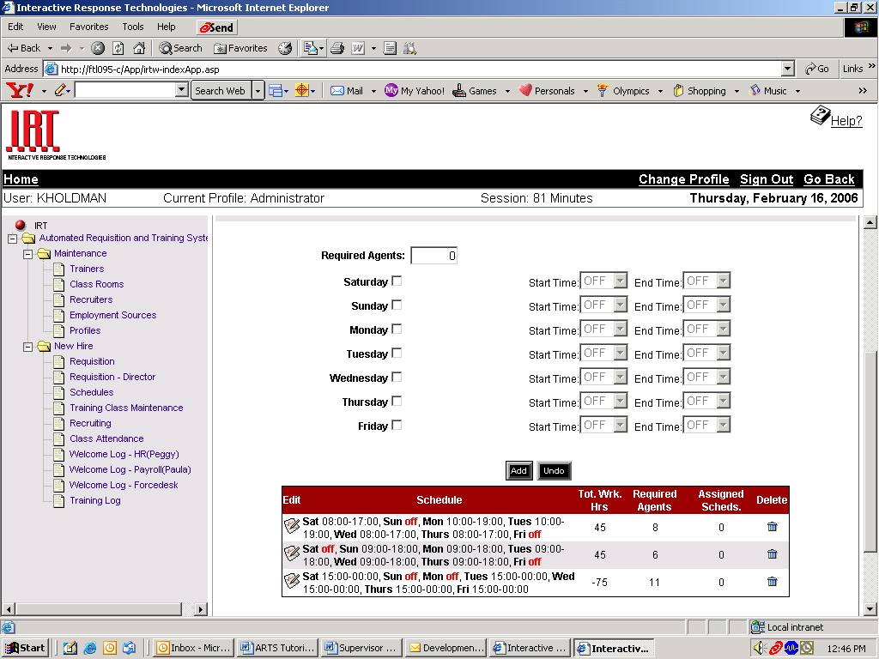
- To delete the newly created schedules select the trashcan icon.
- Selecting the Undo button will erase all times entered.
- To create additional shift times repeat the process until all schedules for the required number of vacancies has been created.
- Once all schedules have been created for the number of vacancies in the class, select Update Schedules
NOTE: if more schedules are inserted than the number of vacancies a pop-up will alert you, however it will not prevent you from entering the additional schedules.

- Notification E-mail

Subject Line: | Schedules Created for (Account Name) Requisition #_
Content: | Schedules have been created for Requisition # Client (Account Name)

Edit Schedules (Force Desk only)
- On the menu located along the left of the screen; select Schedules listed under New Hire and select the requisition in question
- Scroll to the schedule preview screen and select the Edit button to the left of the schedule you would like to change
- Make the edits and select Apply
- The screen will default back to the preview screen so you can confirm the edits have been applied.
- Notification E-mail

Subject Line: | Schedules Changed for (Account Name) Requisition #_
Content: | Schedules have been changed for Requisition #_ Client (Account Name)

Requisition Director

Approve/Decline a Requisition
- On the menu located along the left of the screen; select Requisition – Director listed under New Hire
- Complete the search criteria fields of Client and Status; for Status select Pending
- Select and open the pending requisition to be approved/declined
- Scroll to the Requisition Status section
- Select Approved or Declined in the Status field by using the drop-down arrow
- Enter applicable comments; If declining a requisition, please enter reason(s) in the Comments section
- Select the Update button
- Notification E-mails

Subject Line: | Requisition for T-Mobile has been Approved
Content: | Requisition # 1 for T-Mobile has been Approved.
Subject Line: | Requisition for T-Mobile has been Declined.
Content: | Requisition # 1 for T-Mobile has been Declined.

Training Class Maintenance

Assign a Trainer/Classroom to an Approved Requisition

- On the menu located along the left of the screen; select Training Class Maintenance listed under New Hire
- Select the Unassigned Training tab
- Select the requisition in question from the list displayed

Requisition Information
- This section will display the Requested Training Start date as well as the Go-Live Date. This section is for your information only and requires no action

Training Class Information
- Select the Instruction Type by selecting from the drop-down list
- Enter any applicable Comments

Schedule Information
- Make any necessary change to the Training Start Date (based on Trainer/Classroom availability)
- Enter the End Date of training (different than the Go-Live Date)
- Enter the Start Time and End Time of each training day in military format
- Select the Days of Training (usually Mon – Fri) by placing a checkmark next to the day (do not place a checkmark next to the days on which no training will occur)
- Go to Classroom and select Search; a list of the possible classrooms for the training location (Headway, Ada, Miramar) will appear.
- Assign a classroom by clicking on the desired option
- Go to Trainer and select Search; a list of trainers from all IRT locations will appear.
- Assign a trainer by clicking on the desired name.
- Select Add once all above information has been entered.
- A Training Class Schedule will populate listing the day, date, start time, and end time of each scheduled training day.
  - Should an individual day need to be edited simply select the Edit button on the far left and enter the new times on the form that appears. Select Done once the selection is edited.
  - Should an individual day need to be deleted, simply select the Delete button on the far right; a pop-up will appear asking you to confirm. Select Done once the deletion is complete.
NOTE: If there is a conflict with a trainer or classroom this screen
(Training Class Update) will indicate the nature of the conflict next to the training days in question.
- The screen will return to the main Schedule Information screen; select Add once again to assign the training and update all information.

- Notification E-mail

Subject Line: | Training Class for (Account Name) requisition#_ has been scheduled
Content: | Training Class # _ has been scheduled for requisition #_.
 | Client: (Account Name)
 | Trainer: Mark Schneider
 | Class Room: Training Room #1
 | Date: 3/6/2006 - 4/14/2006
 | Time: 9:00 - 18:00
 | Please go to ARTS for more details.

Make Changes to an Assigned Training Class
- On the menu located along the left of the screen; select Training Class Maintenance listed under New Hire
- Select the Assigned Training tab
- Select the requisition in question from the list displayed
- Go to the information to be changed / updated which will be located under the Training Class Information and/or Schedule Information sections.
- Make the required changes
- Select Update

NOTE: if a pop-up window appears with class times listed in red, it indicates a conflict of trainers or training rooms (i.e. you are requesting a change to a trainer that is already scheduled or a classroom that is already schedule). If you want to proceed with the change simply scroll to the bottom of the pop-up screen and select DONE. When the pop-up screen disappears, select UPDATE on the Training Class Maintenance screen.

- Notification E-mail
Subject Line: | Training Class for (Account Name) requisition#_ has been updated
Content: | Training Class # for requisition #_ has been updated
 | Client: (Account Name)
 | Trainer: Mark Schneider
 | Class Room : Training Room #1
 | Date: 3/6/2006 - 4/14/2006
 | Time: 9:00 - 18:00
 | Please go to ARTS for more details

To Adjust a Training Class Schedule
(Change Training Start and/or End Dates, delete a training day such as a holiday, etc.)

To Delete a Day from the Training Class Schedule
- On the menu located along the left of the screen; select Training Class Maintenance listed under New Hire
- Select the Assigned Training tab
- Select the requisition in question from the list displayed
- Go the Schedule Information section and select Generate Class Schedule
- Locate the scheduled day that you would like to delete and select the Trash Can Icon located in the far right column.
- Close the Class Schedule window (use x in upper right hand corner) returning to the Training Class Maintenance screen.
- Select Update at the bottom of the screen to save the change.

To change the Training Start/End Date
- On the Training Class Maintenance Screen – Assigned Training Tab, select the requisition you would like to change.
- Go the Start Date and/or End Date field and select the drop-down arrow to populate the calendar
- Select the new date
- Select Update at the bottom of the screen to save the change.

To Delete a Training Class (prior to Start Date)
- On the Training Class Maintenance Screen – Assigned Training Tab, find the requisition you would like to delete. Select the trash can icon located to the far right of the line entry under the Delete column
NOTE: Training Class cannot be deleted once the class begins.
Recruiting

- On the menu located along the left of the screen; select Recruiting listed under New Hire
- Select the Client and Status fields to display the desired requisition(s)
- Open the requisition for which you would like to create a Welcome Log.
- 3 Tabs will appear:
- Requisition = displays the requisition information and ability to view Position Profile and Class Schedule details
- Training Class = displays details of the assigned Training Class and ability to view Class Scheduled details
- Welcome Log = the current welcome log for the Assigned class. If no agents have been recruited for the selected class, then the log will be blank.

Requisition Tab

To enter the number of recruits to be recruited and number to begin class
- On the Requisition Tab, complete the # Required to Begin Class field located on the lower left-hand portion of the screen. # Required to Begin Class represents the number of trainees that Recruiting would like to begin class – which will be higher than the Target Yield of agents indicated on the requisition that the program requires to graduate.
- On the Requisition Tab, complete the # Required to be Recruited field located on the lower right-hand portion of the screen. # Required to be Recruited represents the number of candidates that must be recruited and made offers to in order to have the # Required to Begin Class actually show up for class.
NOTE: The system will not allow any entries to the Welcome Log until the # Required to Begin Class field is complete. If not completed, an error message will appear – “Please Enter # Required to Begin Class” and directs the user back to the Requisition Tab so the necessary information can be entered.
NOTE: If a change is made to the Required Headcount on a Requisition by the Program Manager at any time after the initial requisition was submitted, then Recruiting will need to return to the Requisition Tab and adjust both the # Required to Begin Class and the # Required to be Recruited fields.

Welcome Log Tab

To insert a new candidate into the Welcome Log
- Go to the Welcome Log tab
- Select Add New
- Complete the following fields:
    - First name
    - Last name
    - Type of employee
    - Date of offer
    - Hire date – will auto populate with class start date
    - Source; if Referral, enter the referring employee’s name in Referral field
    - Recruiter
    - Transfer – check only if agent is transfering from an existing IRT account
    - If a second interview is needed for recruits (this would have been indicated on the original Requisition entered by the Program Manager) then once completed, the recruiter will place a checkmark in the Second Interview Complete? box.
    - If the Second Interview Complete? box is checked, the Interview By field must be completed by choosing the name of the person who conducted the second interview.
    - Select schedule by clicking on Select Schedule and inserting a check mark next to the assigned schedule
NOTE: a schedule can be assigned more times than the number of schedules available for that shift indicates. For example: if there are 5 shifts available for 9:00-5:00, it can be assigned to more than 5 candidates on the Welcome Log; since we at times recruit/hire more than the requisition indicates.
    - BG Status – no action is necessary. The Background Check field will be completed by a member of IRT’s Fraud and Loss Prevention team once the information has been obtained.
    - Bilingual – place a checkmark in the Bilingual indicator if the employee has been hired specifically as a Bilingual agent.
    - Select Add once all information has been entered for the new hire
NOTE: if a required field has not been completed the Welcome Log will not be updated – a message will appear at the top of the new entry form indicating what information is missing so the user can complete the required information.

To insert an existing Active Production agent into the Welcome Log
- Follow the instructions above for New Candidate with the following changes:
- Select CTRAN as the source code
- Insert a checkmark next to Transfer so employee’s payroll is not affected & they retain their current ABRA ID

To drop a candidate from the Welcome Log
- On the Welcome Log, locate the entry that you would like to drop from the Welcome Log
- Select the Edit icon located to the immediate left of the candidate name
- Once the Edit screen opens, locate the Drop Code field (top right) and select the applicable drop code from the drop-down list. (see Term Codes in the ARTS tutorial)
- Select Update located at the bottom of the Edit Screen
- The entry in question will be “dropped” to the bottom portion of the Welcome Log Removed From Recruiting List.

To Reactivate a candidate previously dropped from the Welcome Log
- On the Removed From Recruiting List, select the Reactivate button located along the right side of the list.
- A pop-up message will ask you to confirm that you would like to reactivate the candidate.
- Select Okay on the pop-up message and the candidate will be once again added to the Class List.

To update a Welcome Log entry (before or after class has begun)
- On the Welcome Log, locate the entry that you would like to edit
- Select the Edit icon located to the left of the entry
- The record will open – edit the information – select Update.

To update BG Status (Background Status) formerly Pending Paperwork status
CAN ONLY BE PERFORMED BY INDIVIDUALS WITH SECURITY LEVEL ACCESS
- On the Welcome Log, go to the BG Status column and using the drop-down arrow select Approve or Decline.
- Select Update at the bottom of the Welcome Log
- If the BG Status is being changed to Decline, the next step may be to drop the agent from the Welcome Log. If so, the DBC drop code would be used when dropping the agent.
- You can also change the BG Status by opening the agent record on the Welcome Log (Select the Edit icon located to the left of the entry)
- The BG Status field is located in the lower left-hand corner of the screen beneath the Select Schedule button
- Using the drop-down arrow select Approve or Decline
- Select Update at the bottom of the Edit screen
NOTES:
- If the class has a status of “Complete”, you can change the BG Status; however you cannot drop or term the agent in ARTS – the termination would have to be completed in AIM.
- If an agent is indicated on the Welcome Log as Show-Up; you can change the BG Status; however they cannot be dropped from the class. The Show-Up indication would have to be un-checked / select Update. The record can then be dropped.

To update Pending Second Interview Status
NOTE: to insert Second Interview requirement see Open a New Requisition
  - Until the second interview has been completed, the Pending Second Interview button will remain checked on the Welcome Log list of candidates.
  - Once the second interview has been completed, open the individual candidate entry by selecting the Edit icon next to the candidate’s name on the Welcome Log.
  - Place a checkmark in the Second Interview Complete? box indicating it has been completed.
  - Indicate who conducted the second interview by selecting from the list of names found in the Interview By field.
  - Select Update to update the entry with the new information.

To complete a Welcome Log (on first day of training)
- On the Welcome Log place a checkmark next to the new hire name in the Show Up column once the new hire reports to class on the first day of training.
NOTE: Unless previously deleted, a new hire record will remain on the Welcome Log, even when it is indicated that they did not show up for class. For example: If a new hire did not show up the first day of class, the Show Up box would not be checked, however the record will remain on the Log.
- Select Update located at the bottom of the form
- Notification E-mail

Subject Line: | Training Class # 1000 for requisition #2 has started.
Content: | Client: T-Mobile
 | Trainer: Mark Schneider
 | Class Room : Training Room #1
 | Date: 3/6/2006 - 4/14/2006
 | Time: 9:00 - 18:00
 | Please assign abra id's.
The email will be forwarded to Training (for class attendance) and HR (for assignment of ABRA ID’s)

To add entries to a Welcome Log once class has begun
- On the Welcome Log select Add New and follow the same process for inserting a name into the Welcome Log prior to training.
- Insert a checkmark in the Show Up box
- Select Update on the Welcome Log
- Notification E-mail
Subject Line: | Welcome Log for Training Class # N/A Client T-Mobile has been modified.
Content: | Welcome Log for Training Class # N/A Client T-Mobile has been modified.
 | Client: T-Mobile
 | Trainer: Mark Schneider
 | Class Room : Training Room #1
 | Date: 3/6/2006 - 4/14/2006
 | Time: 9:00 - 18:00
 | Please go to ARTS for more details.

To change the Bilingual status of an agent once class has begun
If the agent is in Training, and their Bilingual status changes, the change is made on the Welcome Log by Recruiting:
- Go to ARTS / Recruiting / Welcome Log tab
- Locate the agent on the log and open their record by clicking on the Edit icon
- The bilingual indicator is located toward the bottom of the screen;
- Click in the box to place a checkmark and indicate the agent as Bilingual
- If a checkmark appears, click in the box to remove the checkmark and indicate the agent as Non Bilingual
- Select Update to save your changes

To update/modify a candidate’s name on the Welcome Log after class has begun
- On the welcome log, locate the entry that you would like to edit
- Select the Edit button located to the left of the entry
- The record will open – edit the information – select Update.

- Notification E-mail
Subject Line: | Agent's name has been modified.
Content: | Agent's name has been modified.
 | Agent Name: Danniel Portman before Dan Portman.
 | Abra ID:
 | Client: CLG FTL.
 | Training Class #1003.

To reactivate a termed agent during training
NOTE: This can only occur during training – once an agent has been termed. Only Recruiting can reactivate an agent during training.
- Select the desired requisition
- Go to the Welcome Log tab under Recruiting
- Scroll to the agent record on the Class List
- Select the Edit button located to the left of the agent’s name
- The agent information screen will appear – scroll to the bottom and select Reactivate Agent.
- The entry will now appear on the Training Log Class List and will no longer appear under Training Log Removed from Class List
- Notification E-mail
Subject Line: | Agent Eric Halby has been reactivated.
Content: | Agent Eric Halby has been reactivated.

To transfer a candidate from one Welcome Log to another prior to class
- Go to Recruiting and select the requisition number of the Welcome Log where the candidate is currently located.
- Locate the candidate’s record on the Welcome Log
- Select the Edit button located to the left of the candidate’s name
- Go to the Drop Code field and select the appropriate drop code.
DTRAN – to be used if an agent shows up for a training class for which we over-hired, and are now transferring the agent to another class
PTRAN – to be used if agent is transferred from one Recruiting Log to another due to the original class being cancelled, pre-poned or postponed
NOTE: Using one of these drop codes will prevent the candidate from being termed or an ETDL from being completed.
- Once the DTRAN or PTRAN code is selected, a Program field will appear. Using the drop-down arrow, select the program to which the agent will be transferred.
- A Requisition field will appear. Select the Requisition # of the Welcome Log you would like to transfer the candidate to.
- Select Update
- The agent will appear below in the Removed from Class List and their record will now appear on the Welcome Log of the Requisition indicated above.
NOTE: The agent’s original schedule will transfer with the record.
- Go to the Welcome Log for the class that the candidate will be transferred to and locate the candidate’s record.
- If the candidate will be assigned a new schedule based on what is available in the requisition, select the Select Schedule button and place a checkmark next to the desired schedule.
- Select Update
- If the agent will be retaining their original schedule, no action is required.
- The agent is now successfully transferred to the new Welcome Log

To transfer an agent from one class to another during training
Step 1 Training:
- Go to Class Attendance menu item and locate the class # the agent is being transferred from and open the Training Log
- On the Training Log locate the agent’s record and select the Edit button to the far left of the agent’s name.
- Go to the Status field and change the agent status from Active to Transferred
- Go the Term Date field and enter the date of the transfer
- Go the Term Code field and select the TTRAN code. Be sure to select TTRAN and not DTRAN or PTRAN.
- Once the TTRAN code is selected, a Program field will appear. Using the drop-down arrow, select the program to which the agent will be transferred.
- A Class # field will appear. Select the Class to which the agent will be transferred.
- Select Update on the agent record – click Close to exit the agent’s record.
- On the Training Log, select Update and the agent’s record will appear below in the Removed From Class List
- The agent’s record will now appear in the Welcome Log of the class they have been transferred to and Recruiting will need to process the record before it appears in the Training Log of the class they have been transferred to.
NOTE: The agent’s original schedule will transfer with the record.

Step 2 Recruiting:
- Go the Welcome Log for the class the agent is being transferred to
- The agent’s record will now appear on that Welcome Log; select the Edit button to the far left of the agent’s name to open the record.
- Insert a checkmark next to Transfer:
- If the candidate will be assigned a new schedule based on what is available in the requisition, select the Select Schedule button and place a checkmark next to the desired schedule.
- Insert Comments, if needed
- Select Update
- Place a checkmark in the Show Up column of the Welcome Log by clicking in the box
- Select Update
- The record will now appear on the Training Log of the new class

Welcome Log – HR
- On the menu located along the left of the screen; select Welcome Log - HR listed under New Hire
- Select the Client from the drop-down list at the top of the screen (list defaults to All Clients) and select Go
- Select the requisition you would like to work on
- A list of all new hires that have showed for class will appear. Enter an ABRA ID for each. When complete, select Update

- Notification E-mail
Subject Line: | Abra Id's for Training Class # 1000 Client T-Mobile have been created.
Content: | Abra Id's for Training Class # 1000 Client T-Mobile have been created.  Please enter them in Payroll.

To enter an ABRA number for a new hire that joins class late
- Follow the same process as above

Welcome Log – Payroll
- On the menu located along the left of the screen; select Welcome Log – Payroll listed under New Hire
- Select the Client from the drop-down list at the top of the screen (list defaults to All Clients) and select Go
- Select the requisition you would like to work on
- A list of all new hires that have showed for class will appear. Once each new hire has been processed in Payroll, check the Process box. Once all new hire employees have been processed, select Update
- Notification E-mail
Subject Line: | Training Class # 1000 for T-Mobile has been entered into Payroll.
Content: | Agents from Training Class # 1000 Client T-Mobile have been entered into Payroll.  Please create Agent Id's.
To process payroll records for a new hire that joins class late
- Follow the same process as above

Welcome Log – Force Desk
- On the menu located along the left of the screen; select Welcome Log – Force Desk listed under New Hire
- Select the Client from the drop-down list at the top of the screen (list defaults to All Clients) and select Go
- Select the requisition you would like to work on
- A list of all new hires that have showed for class will appear. Enter an employee ID for each new hire. Once all new hire ID’s have been entered, select Update

- Notification E-mail

Subject Line: | Agent Id's for Training Class # 1000 Client T-Mobile have been created.
Content: | Agent Id's have been created for Training Class # 1000 Client T-Mobile.

NOTE: Welcome Logs will not be viewable in the system once the necessary information required has been entered or processed. If you would like to view an ABRA ID or an employee ID once they have been created, go to the Training Log.

Training Class Attendance

Hours for each agent in training will be entered into the IRT Payroll System by the trainer on a daily basis. Time entered into the Payroll system should represent tardiness, absences, etc. Time entered into the Payroll system by the trainers can be viewed in ARTS (see below).

The only information that will be entered in the ARTS system by the trainers in the Class Attendance section is terminations, certifications, and issued headsets.

To view the hours of class attendance THAT HAVE ALREADY BEEN ENTERED INTO PAYROLL (hours not yet entered into Payroll cannot be viewed in ARTS)
- On the menu located along the left of the screen; select Class Attendance listed under New Hire
- Select the requisition in question by;
  - Complete the Client and Status fields at the top of the form and selecting Go; this will populate a list of requisitions for the client and status indicated only; click on the selected requisition # (far left column)
  - OR simply scroll down the list of requisitions and locate the requisition you would like to view and click on the requisition # (far left column)
- Click on the Payroll Hours tab located across the top to view any Payroll-entered time for the day(s) indicated.

To terminate an agent from class:
Begin from ARTS / New Hire / Class Attendance
- Go to the Training Log
- Open the agent record by clicking on the Edit button to the left of the name (pencil & paper)
- Go to the Status field and using the drop-down options select Termed
- Go to the Termed Date field and using the drop-down calendar select the agent’s termination date.
- Go to the Term Code field and using the drop-down options select the term code that best describes why the agent is no longer with IRT (see Term Codes in the ARTS tutorial)
- Select Update at the bottom of the form
- The automated ETDL form will display
- Complete Agency? By selecting Yes or No
- Complete Voluntary? by selecting Yes or No
IMPORTANT NOTE: if an agent is being terminated due to Job Abandonment, it is considered Voluntary
- Complete 2-wk Notice Given? by selecting Yes or No
- Last Day Worked field will populate with the Termination date chosen on the previous form – if the last day the agent worked is different from the termination date you can change the date by using the drop-down calendar.
- Scroll to Section B and using the drop-down selections choose the correct Reason for Termination.
- Based on the Reason selected specific details will display in the Detail field; choose the applicable Detail
- Select ADD to complete the ETDL process
IMPORTANT – If the ETDL form is not completed prior to the ARTS system closing, the agent may display as Termed (below the line); however no ETDL will be generated. In that case have Recruiting reactivate the agent from the Welcome Log so that the Trainer can go into the Training Log and re-do the termination ETDL
IMPORTANT – once the ETDL has been generated by selecting ADD, a termination can only be reversed by opening a HELP DESK ticket. Please be sure that the termination is accurate before completing this process
- Select Close to close the agent record and return to the Training Log
- the agent should now appear at the bottom of the Training Log in Removed From Class List

- Notification E-mail

From: KHoldman@callcenter.com [mailto:KHoldman@callcenter.com]
Sent: Tuesday, January 15, 2008 3:18 PM
To: ETDL Distribution List
Subject: Houston - Term – TOM SMITH 123456. Abra Id: 98765

Employee Name: TOM SMITH
Agency? N
Works Status: TRN
Location: Houston
Department/Client: Bank Of America CF
Mgr./Supervisor: SERGIO AGUILAR
Termination: Voluntary? N
2-wk notice given? N
Last Day Worked: 1/14/2008

To complete the Training Log
Trainers or Training Managers:
- Go to Class Attendance menu item in ARTS and a list of current classes scheduled will appear
- Locate the class to be completed and click on the link located to the far left – this will open the Training Log and Payroll Hours
- For each agent listed on the Training Log indicate if the agent completed certification and was certified:
FOR ALL PROGRAMS EXCEPT ATT:
- Place a checkmark in the Certified box for each agent that is certified
- Select Update at the bottom of the log
FOR ATT PROGRAM ONLY
  - Open the agent record by selecting the Edit button located to the left of the agent name
  - Enter a checkmark in the Certification box
  - Enter a certification date by using the drop-down arrow of the calendar in the Certification Date field
  - Select Update to update the agent record
  - Select Done to close the agent record
  - Do the same for each agent certified
- For each agent listed on the Training Log indicate if the agent received a headset by entering a checkmark in the Headset box.

To complete the Training Class
Trainers or Training Managers:
- Go to the Training Class Information section located at the top of the Training Log
- In the Trn Status field use the drop down arrow and select Complete
- Select Update at the bottom of the Log
NOTE: A requisition cannot be closed until the Training Class is complete

- Notification E-mail

Subject Line: | Training Class # 1000 for T-Mobile has been completed.
Content: | Training Class #1000 for T-Mobile has been completed
Client: T-Mobile
Classroom: Training Room #1
Date: 3/24/096 – 4/14/06
Time: 9:00 – 6:00
Please go to ARTS for more details
PM please close requisition
HR please change security badges
Payroll/HR please make appropriate rate changes.

To transfer an agent from one class to another during training
Step 1 Training:
- Go to Class Attendance menu item and locate the class # the agent is being transferred from and open the Training Log
- On the Training Log locate the agent’s record and select the Edit button to the far left of the agent’s name.
- Go to the Status field and change the agent status from Active to Transferred
- Go the Term Date field and enter the date of the transfer
- Go the Term Code field and select the TTRAN code. Be sure to select TTRAN and not DTRAN or PTRAN. TTRAN should be the last code in the list.
- Once the TTRAN code is selected, a Program field will appear. Using the drop-down arrow, select the program to which the agent will be transferred.
- A Class # field will appear. Select the Class to which the agent will be transferred.
- Select Update on the agent record – click Close to exit the agent’s record.
- On the Training Log, select Update and the agent’s record will appear below in the Removed From Class List
- The agent’s record will now appear in the Welcome Log of the class they have been transferred to and Recruiting will need to process the record before it appears in the Training Log of the class they have been transferred to.
NOTE: The agent’s original schedule will transfer with the record.

Step 2 Recruiting:
- Go the Welcome Log for the class the agent is being transferred to
- The agent’s record will now appear on that Welcome Log; select the Edit button to the far left of the agent’s name to open the record.
- Insert a checkmark next to Transfer:
- If the candidate will be assigned a new schedule based on what is available in the requisition, select the Select Schedule button and place a checkmark next to the desired schedule.
- Select Update
- Place a checkmark in the Show Up column of the Welcome Log by clicking in the box
- Select Update
- The record will now appear on the Training Log of the new class

Training Log
This is a view-only screen for parties that would like to view class headcount as a class progresses.
To view a Training Log
- On the menu located along the left of the screen; select Training Log listed under New Hire
- View the requisitions listed and select the Training Log you would like to view

If you do not see the requisition/Training Log that you would like to view:
- Enter the search criteria fields of Client, Start Date, and End Date.
NOTE: The start date of the training class must fall within the noted start date and end date range for the Log to appear on the list.
- Select Go; a list of training classes that began within the date range entered will appear.
- Select the Training Log you would like to view.

To print a Training Log
- To print a copy of the Training log, click on the Export to Excel button located on the Training Log tab.
- Once the Excel version opens select File – Page Setup from your Standard toolbar
- On the Print screen that appears select Landscape; select Fit to One Page
- Select OK
- The version that prints will include:
    - Agent name
    - Certified Y or N
    - Headset Issued Y or N
    - Agent ID
    - Recruiter
    - Trainer Notes

To view Training Payroll Hours
- On the menu located along the left of the screen; select Training Log listed under New Hire
- View the requisitions listed and select the Training Log you would like to view
- Scroll down and select the Payroll Hours tab. Any hours listed in the Payroll system to date will appear for the dates listed.

Close a Requisition / Changing the Status of a Requisition
Note: only a Program Manager can close a requisition or change the status of a requisition
  - On the menu located along the left of the screen; select Requisition listed under New Hire
Requisition Status Definitions
    - Pending = requisition submitted but not yet approved
    - Approved = requisition approved and in any stage of the Recruiting and/or Training process
    - Decline = requisition reviewed and declined by EVP
    - Cancelled = requisition was approved, but cancelled by PM at any time during the Approval, Recruiting and/or Training process
    - Closed = training is complete and PM has closed the requisition

To close a requisition once training has been completed
- Select the search criteria of Client and Status to view a list of requisitions that can be closed. Under Status, select Approved to close a requisition for which training is complete.
- Select the requisition to be closed and once opened scroll to the Requisition Status section.
- In the Status field select Closed using the drop down selections
- Go to the Disposition field and using the drop-down selections, select the appropriate disposition;

Disposition Definitions
    - Headcount Satisfied = the required headcount that was requisitioned has been met and the new agents are in production.
    - Headcount Not Satisfied – No Sub-Req = the required headcount was not produced from the completed training class, however at this time no sub-requisition is required.
    - Headcount Not Satisfied – Sub-Req = the required headcount was not produced from the completed training class, and a sub-requisition is required. (See To Open a Sub-Requisition)
  - Enter applicable comments in the Comments field
  - IMPORTANT - Select Update to close the requisition

- Notification E-mail

Subject Line: | Requisition #1 for CLG FTL has been closed.
Content: | Requisition # 1 for CLG FTL has been closed
 | Please go to ARTS for more details.

Open a Sub-Requisition
  - On the menu located along the left of the screen; select Requisition listed under New Hire
  - Select the Client and select Status: Closed
  - For the Start Date and the End Date select a date range for the closed requisition
NOTE: the date range should be indicative of when the original (parent) requisition was closed. For example: If the class started on 03/01/06, completed on 03/05/06, and was closed on 03/08/06, the End Date field should show 03/08/06 or later for the requisition in question to appear.
  - Select the requisition for which you would like to create a sub-requisition.
  - Scroll to the Requisition Status section and select the New Sub-Requisition button
  - A new requisition form will appear that will have the parent requisition information included, i.e. Client, Position, etc.
  - Complete the Requisition form (See Open a New Requisition for details)
  - Scroll to the bottom of the form and select Add

- Notification E-mail

Subject Line: | A new requisition has been created for (Account Name)
Content: | A new requisition has been created for (Account Name) Requisition #3-2. Please create schedules.

NOTE: A sub-requisition will be always indicated by the requisition #. A sub-requisition number will consist of the new requisition number / dash / parent requisition number. Example: Requisition #3-2

View Declined/Cancelled/Closed Requisitions
- On the menu located along the left of the screen; select Requisition listed under New Hire
- Complete the search criteria fields of Client and Status
    - For the Start Date and the End Date select a date range for the requisition you would like to view
NOTE: the date range should be indicative of when the original (parent) requisition was declined/cancelled/closed. For example: If the class started on 03/01/06, completed on 03/05/06, and was closed on 03/08/06, the End Date field should show 03/03/06 or later for the closed requisition in question to appear.
    - Select the requisition you would like to view.

Maintenance
The Maintenance section is where information about selected topics can be updated, edited, added, or deleted
- On the menu located along the left of the screen; select the area you would like to edit listed under Maintenance
    - Trainers
    - Classrooms
    - Recruiters
    - Employment Sources
    - Profile
Trainers
- You may select a specific location to view only trainers from that location
- Select GO
- Or simply scroll through the list of all IRT trainers:
- To edit a record click on the trainer name, Update or insert the information and select Update
NOTE: if you opened a New Trainer form by mistake, simply select your Back browser button to exit
- To add a trainer to a list select New, complete the form, and select Add
- To delete an entry select the trash can icon to the right of the entry
Classrooms
- Follow same process as above (Trainers) to edit/add/delete a Classroom entry
Recruiters
- Follow same process as above (Trainers) to edit/add/delete a Recruiter entry
Employment Sources
- To edit an entry click on the name and once the record opens, edit and select Update
- To add an entry select New, complete the form, and select Add
- To delete an entry, click on the trash can icon to the right of the entry
Profiles
    - Select the client (account) name and select Go
    - The Agent Job Function will appear.
    - To edit select Agent located in the Position column and once the record opens, edit the select fields and select Update.
    - To return to the Job Function screen select the back (browser) button.
    - To delete the entry entirely, select the trash can icon located to the right of the entry
    - To enter a new profile select New, complete all fields, and select Add.
    - To return to the Job Function screen at any time, select the back browser button.
- Notification E-mail

Subject Line: | Agent profile for T-Mobile has been updated.
Content: | Agent profile for T-Mobile has been updated. .

RECRUITING DROP CODES / TRAINING TERMINATION CODES
DROP CODES / During Recruiting Process
Code | Description | Voluntary / Involuntary
PTRAN | Agent transferred prior to training / Agent request | V
NSDT | No Show to drug testing | V
DBC | Background check | I
DDR | Domestic Responsibility | V
DDIS | Discharge dishonesty during recruiting process | I
DIL | Health | V
DNCNS | No show for class | V
DOJ | Other job | V
DRT | Transportation | V
DSC | Schedule conflict | V
DTRAN | Transferred to another class/program | I
TERMINATION CODES / During Training
Code | Description | Voluntary / Involuntary
TAB | Training abandonment | V
TDAT | Attendance / Punctuality | I
TDBC | Background check | I
TDBEHAV | Unprofessional behavior in class | I
TDDIS | Dishonesty | I
TDDT | Drug test | I
TDIS | Insubordination | I
TDMIS | Misconduct | I
TDNTC | Not certified | I
TDPF | Performance | I
TDPV | Policy violation | I
TNJOF | New job other field | V
TNJSF | New job same field | V
TOTH | Other - Discuss w/ HR Mgr | V
TRDOMES | Domestic responsibility | V
TRDWHRS | Dissatisfied with hours | V
TRDWJ | Dissatisfied with job | V
TRIL | Health | V
TRL | Relocating | V
TRNOREAS | No reason provided | V
TRNSTCC | Completed & certified training - No show production | V
TRT | Transportation | V
TSC | School schedule | V
TTRAN | Transfer to another class/program | V

